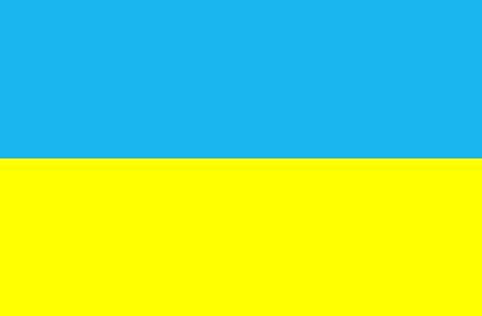
UKRAINIAN SOCIAL ORGANISATION “Amateur Cross-Country Ski Union of Ukraine”

REPORT
of winter and summer seasons 2019
UKRAINIAN MASTERS
The season 2019 was good. Athletes participate in such competitions:
EVENTS | DATE | PLACE | PARTICIPANTS
Ski Racing "New Year starts" | 07.01.19 | Kharkiv | 48
Ski Racing "New Year starts" | 07.01.19 | Sumy | 39
WORLD MASTERS CHAMPIONSHIP | 05-15.03.2019 | Beitostolen (Norway) | 9
Masters’ championship of Ukraine | 21-24.01.19 | Sianki, Lviv region | 64
Cross-country skiing competitions are dedicated to the memory of I. Began | 26-27.01.19 | Sianki, Lviv region | 79
Masters’ championship of Ukraine | 16-20.02.19 | Chernigov | 56
Roller skiing masters championship of Ukraine | 07-09.06.19 | Sumy | 52
Roller skiing championship of masters - "Carpathian Mountains 2018" | 02-04.08.2019 | Vorokhta, Ivano-Frankivsk region | 32
Roller skiing championship of masters - Ecomarathon "Sunrise Svitiaz" | 10-11.08.2019 | Svitiaz | 38
Roller skiing championship of masters | 18.08.2019 | Kharkiv | 22

9 athletes from Ukraine participated in the World Championships in Beitostolen.

Roller ski competitions were conducted in spring, summer and autumn in Kharkiv, Sumy, Vorokhta, Svitiaz. The athletes represented different region of Ukraine (Sumy, Lviv, Kyiv, Kharkiv, Ternopil, Rivne, Lutsk, Ivano-Frankivsk, Poltava, Chernihiv, Dnipropetrivsk and Luhanska).

Best regards,
Tetyana Bilous
National Director of Ukraine.

