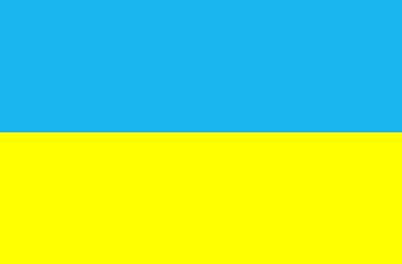
UKRAINIAN SOCIAL ORGANISATION “Amateur Cross-Country Ski Union of Ukraine”

WMA REPORT
of winter and summer seasons 2018
UKRAINIAN MASTERS

The season 2018 was good. Athletes participated in such competitions:

EVENTS | DATE | PLACE | PARTICIPANTS
Ski Racing "New Year starts" | 07.01.18 | Kharkov | 52
Ski Racing "New Year starts" | 07.01.18 | Sumy | 42
WORLD MASTERS CHAMPIONSHIP | 18-28.01.2018 | Minneapolis (USA) | 3
Masters’ championship of Ukraine | 29.01.18-03.01.18 | Skole, Lvov region | 75
Masters’ championship of Ukraine | 22-25.02.18 | Kharkov | 56
Roller skiing masters championship of Ukraine | 08-10.06.18 | Sumy | 59
Roller skiing – Sowie Mountains 2018 | 28-29.07.2018 | Pieszyce, Poland | 5
Roller skiing championship of masters - "Carpathian Mountains 2018" | 02-05.08.2018 | Vorokhta, Ivano-Frankivsk region | 28
Roller skiing championship of masters - Ecomarathon "Sunrise Svitiaz" | 11.08.2018 | Svitiaz | 72
Roller skiing championship of masters | 19.08.2018 | Kharkov | 26

In December because of the lack of snow it was not possible to prepare for the World Championships in Minneapolis in is only the 2 athletes of Ukraine participated in the computation.

The spring, summer and autumn there were conducted competitions with roller skis. The competitions conducted the organizers of regional competitions in Kharkov, Sumy, Svitiaz a good level. This has contributed an active participation of athletes from all cities of Ukraine (Lvov, Kyiv, Ternopol, Rovno, Lutsk, Ivano-Frankovsk, Poltava, Dnepropetrovsk and Luganskay region). We took part in the competition on roller skis in Pieszyce, Poland.
We participated in the competition for roller skis in Pieszyce, Poland.

Best regards,
Tetyana Bilous
National Director of Ukraine.

