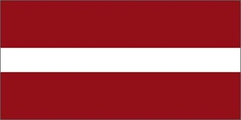

**ANNUAL REPORT**

**Activities of Latvian Masters Cross-Country Ski**

**of winter season 2018**

Winter of 2018 in Latvia was not really different from previous seasons, as it was only a little bit friendly to skiers. On the plus side, below zero temperature was stable for longer periods in major ski centers. At ski center “Smeceres Sils” in Madona we were able to hold artificial snow layer up until end of April, so the skiers around the city always are pretty lucky to have such conditions. Throughout the rest of the country we had stable snow only in February when the major mass events were held. Most of the masters were active during this period.

Every year there is almost constant number of participants which takes part in cross country skiing competitions organized by the Union of Master Sports of Latvia. Basically, it’s because that not only skiers are represented there, but also wide range of other sports enthusiasts and ex-athletes. And this competition goes into overall ranking for masters throughout the year activities. Mostly this explains why so many masters gather here.

As mentioned before, in January and in March competitions were held in sites with artificial snow layer and mostly those events were organized by Latvian Ski Federation. Unfortunately, because of the low attendance, there was only 1 separate age category for master athletes. So it made like endless loop – it didn’t promote masters to be there.

Besides traditional races, there are several local events, where masters are welcome, but, mostly, those are not so popular in overall measures and quite often are held without timing control and with short distance lengths.

During this winter season, with huge thanks to FIS Sub Committee of Rollerskiing Martins Niklass, was started a 3 stage event called “Latloppet”. It took held in various places of Latvia. In every stage the distance length was 20 km and above, with an aim to promote Classical style.

By ignoring Global Warming, master skiers of Latvia keeps a hope that next winter season of 2019 would be great again and are preparing for MWC2019 in Beitostølen.

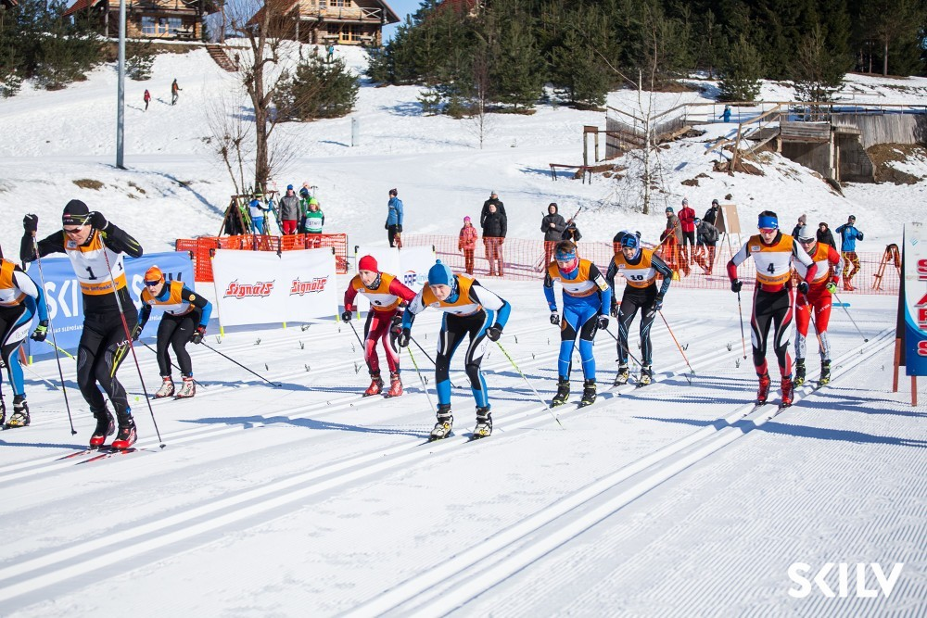

**ANNUAL REPORT**

**Activities Calendar of Latvian Masters Cross-Country Ski**

**of winter season 2018**

|  |  |  |  |  |  |
| --- | --- | --- | --- | --- | --- |
| **DATE** | **EVENTS**  (includes categories for masters) | **LOCATION** | **CATEGORIES, DISTANCE** | **PARTICIPANTS**  **in masters categories** | |
| **January** |  |  |  |  |
| 21.01.18 | Championship of Latvia 1st stage (artifical snow) | Madona  SC„Smeceres sils” | (M01+)-10km C  (W01+ )- 5km C | 5  2 | |
| 24.01.18 | Popular skiing “Smecere 2018” 1st stage (mixed snow) | Madons SC “Smeceres sils” | W(01;05) 2,5km F  M(02;05) – 5 km F | 3  11 | |
| **February** |  |  |  |  | |
| 04.02.18 | Latloppet – 1st (natural snow) | Vietalva SC” Mailes” | W(02;04;06) 20 km C  M(02;04;06) 20 km C | 11  26 | |
| 07.02.18 | Popular skiing “Smecere 2018” 2nd stage (natural snow) | Madona SC”Smeceres sils” | W(02;05) 2,5 km F  M( 01;05) - 5kmF | 5  10 | |
| 10.02.18 | Popular skiing “Aluksne 2018” | Aluksne SC “Mežinieki” | W(05;07) 12km F  M(01;03;05) 18km F | 3  12 | |
| 10.02.18 | Popular skiing “Around Lake Alauksts” | Vecpiebalga | W(02;03;04;05;06) 16km F  M(02;03;04;05;06) 16km F | 26  135 | |
| 10.02.18 | Popular skiing “ The festival of Vanagkalns” | Jaunpiebalgs | W(03;05;07;09) 18km F  M(03;05;07;09) 18km F | 45  102 | |
| 11-12.02.18 | sprint race “Sprints of Riga” | Riga  SC „Victory Park” | ( W03+) 1km F  (M05+) 1 km F | 5  22 | |
| 12.02.18 | Latvian Masters Championship | OC “Priekuļi”  LSVS | W(01-011)- 2-10km F  M(01-011) 2-10km F | 27  82 | |
| 17.02.18. | Latloppet – 2nd  (natural snow and rain) | Lubāna | W(02;04;06)-20km C  M(02;04;06)-20km C | 13  10 | |
| 24.02.18 | Popular skiing “Madona” (natural snow) | Madona  SC„Smeceres sils” | W(01;03;05)– 15km F  M(01;03;05;07)-15km F | 19  81 | |
| 25.02.18 | Latloppet – 3rd (natural snow) | Madona SC”Smeceres sils” | W(02;04;06) 20km C  M(02;04;06)- 20km C | 11  19 | |
| **March** |  |  |  |  | |
| 04.03.18 | Championship of Latvia 2nd stage (mixed snow) | Madona  SC “Smeceres sils” | W01+– 10km F  M01+ – 15km F | -  5 | |
| 18.03.18 | Championship of Latvia 3rd stage (artifical snow) | Madona SC”Smeces sils” | W(01+)-21km C  M(01+)-15km C | 1  3 | |

*Explanation: SC – Skiing Centre; LSVS- Latvian Sport Masters Union*

Andis Puida, *WMA National Director of Latvia 05.09.2018*