

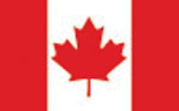

**CANADIAN MASTERS REPORT**

**WMA ANNUAL MEETING**

**SEPTEMBER 2019**

**CANMORE**

While winter came early to most parts of Canada in 2018 it did not have a positive effect on membership in the Canadian Masters as our membership was the lowest in 20 years. From an all time high of 859 in 2011 which was the year Canada last hosted the MWC to 261 this past year.

There was some good news however as 107 Canadians registered for MWC 2019 in Beitostoelen. This was the largest number of Canadians ever to attend a MWC in Europe.

The 2019 Canadian Masters Championships were held in Ontario with 87 people participated. The race schedule was changed from the normal week long event of four races to three races on Friday to Sunday. The hope is that the shortened race schedule will encourage more clubs to host the event.

We look forward to 2021 when the Masters World Cup comes to Canmore, Canada.

Bruce LeGrow

National Director