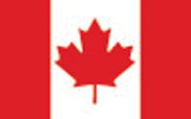

Canadian Masters Report
WMA Annual Meeting
September 2018
Cogne, Italy
The 2017-18 ski season had a good start in Canada with snow in most of the country by December. The weather was once again unpredictable however with extreme cold conditions in parts of the country in January and torrential rain in the others.
Ninety-five Canadian Masters attended the MWC 2018 in Minneapolis which was a very small number. More that twice that number participated when the MWC was in McCall. The Canadian Masters Championships were held in conjunction with the MWC which is the practice when the MWC is held in North America.
Membership in the Canadian Masters dropped by almost 50% for the 2017-18 season as some of the Provinces changed their membership criteria. This is one issue which the Canadian Masters will have to deal with going forward.
Respectfully submitted
Bruce LeGrow

