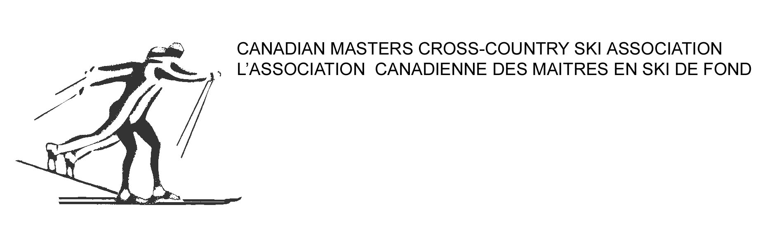

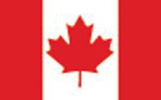

**CANADIAN MASTERS REPORT**

**WMA ANNUAL MEETING**

**NOVEMBER 2020**

With early snowfall in most parts of the country the 2019-20 ski season began with an air of optimism. Interest in MWC 2020 in Cogne appeared to be high as most of the 50 rooms I had reserved were booked fairly quickly and I was confident that while we would not reach the numbers from Beitostolen we would be close. As the ski season moved into the New Year however, reality set in and people started to cancel. By the registration deadline only 44 Canadians had registered which was disappointing from my view point. The disappointment continued however as the MWC 2020 was eventually cancelled.

Covid-19 also resulted in the cancellation of the 2020 Canadian Masters Championships which were scheduled for Labrador City, NL in March 2020. My focus then turned to the MWC 2021 and along with our President we met regularly with the Canmore OC. The OC worked very hard in trying to address all of the obstacles being presented by Covid-19 but finally had to cancel the event. It was very disappointing to have to cancel after the tremendous amount of work by the OC.

We are confident however that after you participate in MWC 2022 you will forget all about the disappointments and heartaches of the past two ski seasons. I look forward to seeing you all in Canmore in 2022.

Bruce LeGrow

National Director