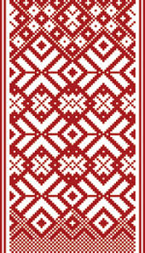
ANNUAL REPORT
Activities of Latvian Masters Cross-Country Ski
of winter season 2020

Once more, like it was a year before - it might be a global warming that impacts the snow layer in Latvia, as well as the rest of the world. Compared to almost-no-snow winter of 2019, the winter of 2020 was almost-no-minus-degrees one. We even didn’t have a decent period to prepare an artificial snow.
Only one skiing base in Madona caught 3 days with temperature around -4 C to prepare 1,5km loop. Week later was scheduled National Championship stage. The problem was that 4 days before that temperature rose to +6 C with a heavy rain at some periods. The organized covered critical points of the track with plastic sheets to protect from the rain. Also the track was closed all the time before the competition.
This event turned out to be the only skiing competition in Latvia in the winter of 2020. The first of two days was an FIS Sprint race, so no masters there, but on the second it was a short distance Free technique race. The loop was 1,5 km and some parts of the track was split in two directions. leaving very narrow corridor to pass, but almost all the participants were happy to have at least one event.
As usually most of the master skiers were gathering in cross country skiing competition organized by the Union of Master Sports of Latvia. As nowadays, most of the races are organized in skating (free style), it was really nice to see a lot of skiers in popular races of three Latloppet skiing stages, which were organized in classical style. From the organizers it is a great initiative to popularize classical technique as the best skiing style for athlete’s body and health. Altogether, 22 masters took part in the race. Not many, but for most of them it was the only time on the snow that season. That lead to the fact, that only 1 of the masters planned to take part in MWC2020, but almost got stuck in Italy.
We really hope for a better winter this season, but the Covid-19 may spoil the racing anyway ☺
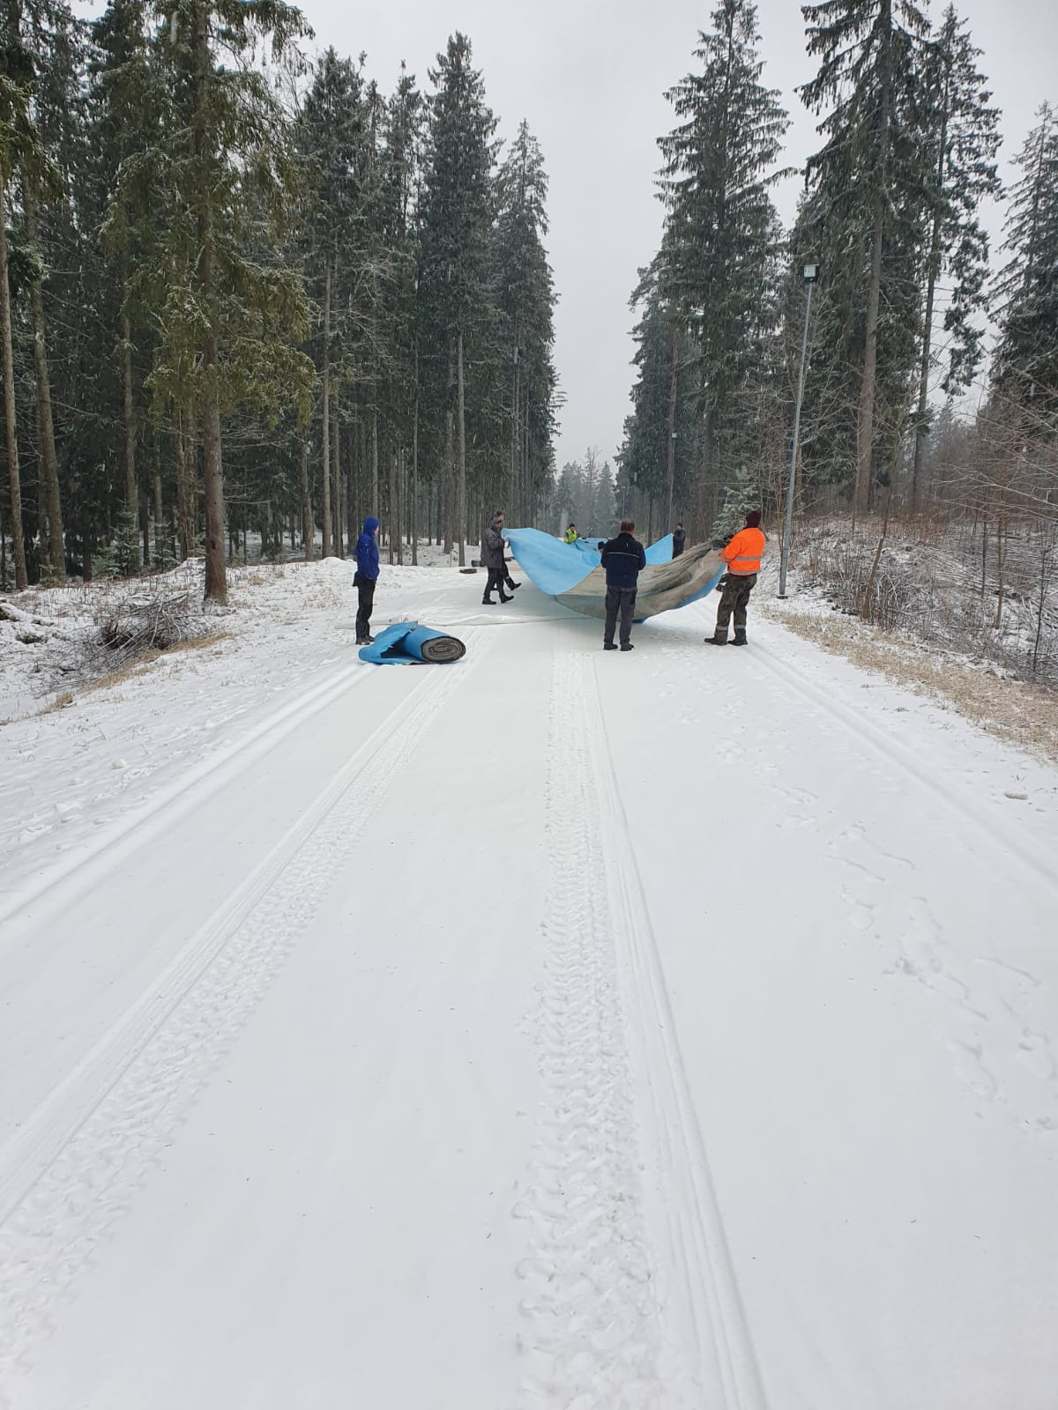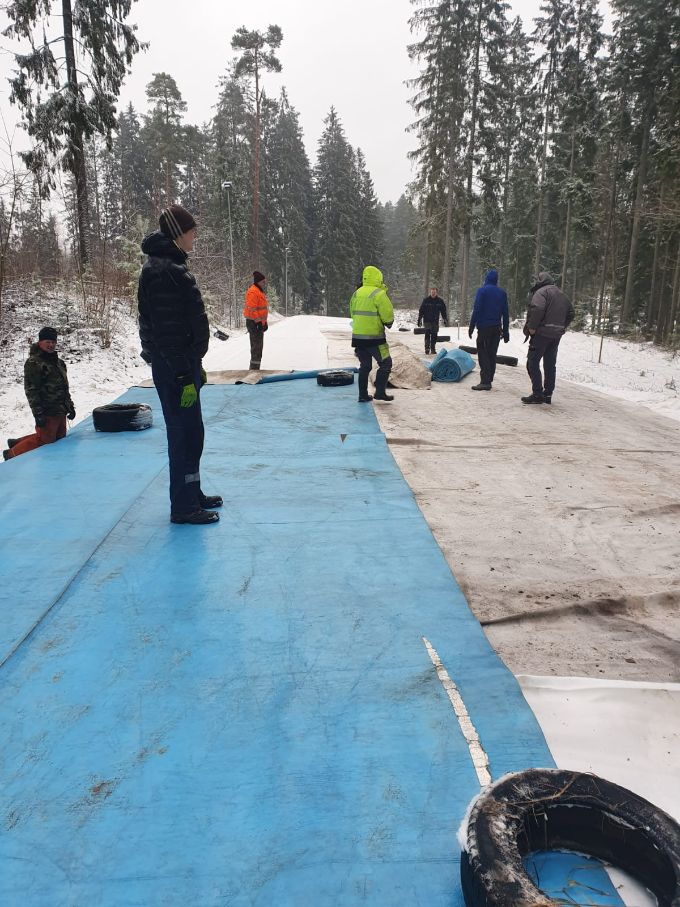

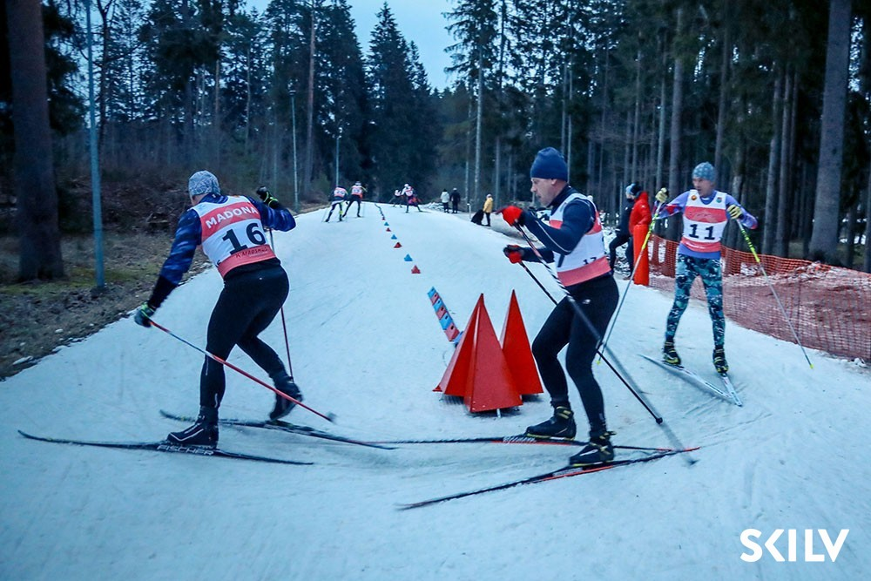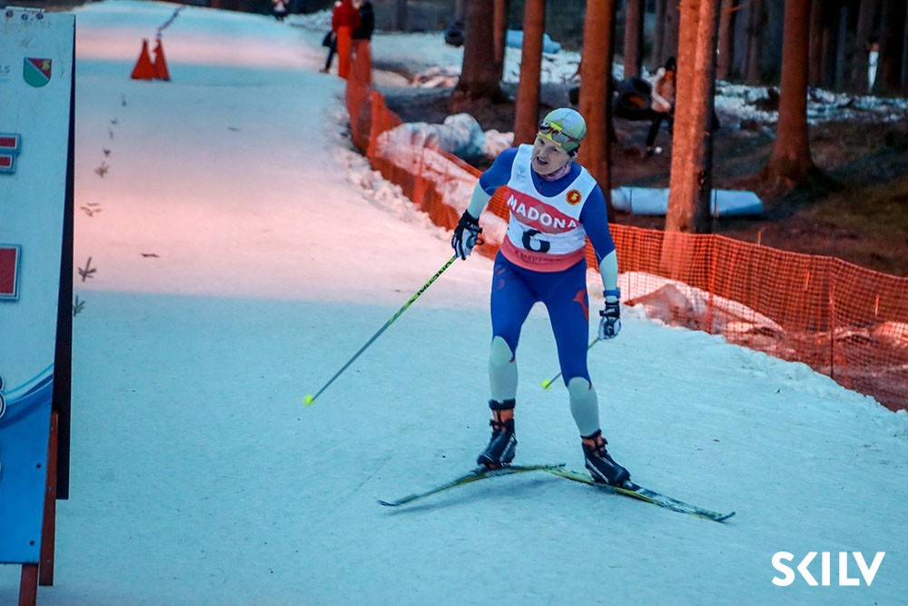

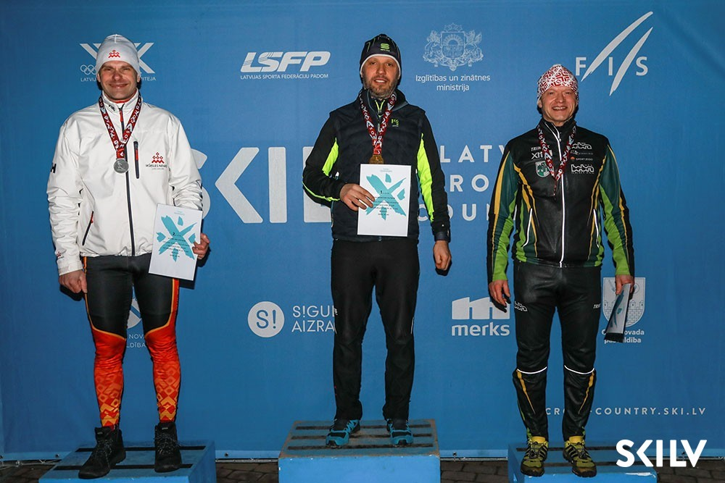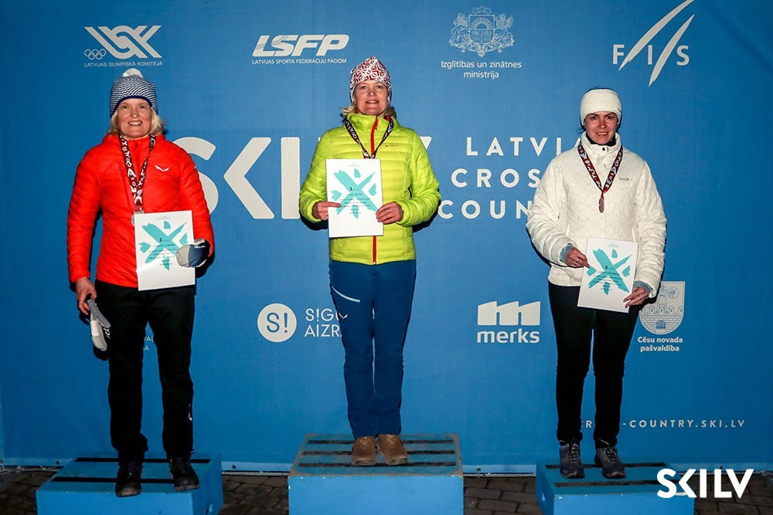

ANNUAL REPORT
Activities of Latvian Masters Cross-Country Ski
of winter season 2020

DATE | EVENTS  (includes masters category) | LOCATION | GROUPS, DISTANCE | PARTICIPANTS  (in masters category)
January
February
16.02.2020. | Latvian Championship (artifical snow,ice) | Madona SC  „Smeceres sils” | ( W04;06+) 5km F  (M04;06) 5km F | 6  16
March
Explanation: SC – Skiing Centre; LSVS- Latvian Sport Masters Union

Andis Puida, WMA National Director of Latvia 28.10.2020

